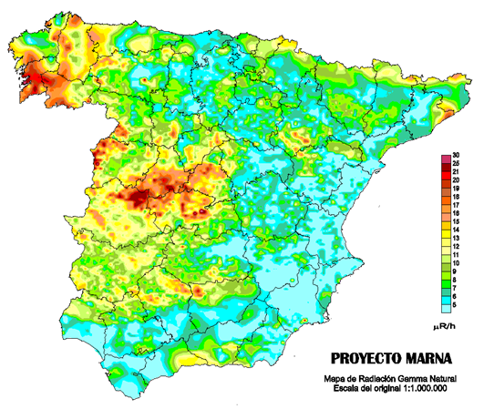
INTERNATIONAL INTERCOMPARISON EXERCISE ON NATURAL RADIATION MEASUREMENTS UNDER FIELD CONDITIONS
Madrid
Saelices el Chico (Salamanca, Spain)
Laboratory of Natural Radiation (LNR)
University of Cantabria, Radon Group (Spain)
May, 23-27, 2011

LAST Announcement

SPONSORSHIP

Dear participant,
We are approaching the opening of our intercomparison exercise. First of all the organizing committee would like to express you its gratitude for your decision on taking part in this event. Second, as we announce you in previous e-mail, it is our great pleasure and a big honour for us to communicate the sponsorship of “CONSEJO DE SEGURIDAD NUCLEAR DE ESPAÑA” (Spanish Nuclear Safety Council).



MEETING POINT:

CIUDAD RODRIGO PLACE, SUNDAY, 22, 12-21 HOURS

CONTACT PHONE: 655 970194

INSTRUCTIONS FOR DELIVERING RADON PASSIVE DETECTORS

Some participants have asked us if it is possible to send radon passive detectors before starting the exercise. The answer is YES and here you can find the instructions to deliver your detectors. It is esential that you follow these instructions in order to get your detectors ready for the intercomparison. It is not the responsability of the organizers if your detectors do not arrive on time due to delays in the delivering service or any other circumstance. Please, pay attention speccially on the dates.
1. All detectors must arrive BEFORE 18 OF MAY 2011.
2. Delivering address:
Grupo Radon - Departamento de Ciencias Medicas y Quirurgicas
Facultad de Medicina
Avenida Cardenal Herrera Oria s/n
39011 Santander
SPAIN
3. Include the instructions to handle the detectors.
- It is necessary 15 passive detectors for each exposure and 15 to be used transits (60 detectors total). If you wish to participate in radon outdoors, you need to provide 15 extra passive detectors.

IMPORTANT NOTE: THURSDAY, 26, 21 h, INFORMAL PARTY & DINNER AT THE LABORATORY

SCHEDULE
DAY | 9h 10h 12h |  | 13h | 14h | 18h 19h
Monday, 23 | RECEPTION |  | OFFICIAL  WELCOME | INFORMAL  LUNCH | RADON IN WATER  &  RADON EXHALATION RATE FROM BUILDING MATERIALS |  | TALKS:  The European Geogenic Radon Map  by Peter Bosew  25 years after Chernobyl accident  By Dr. Chunikhin Leanid Alexandrovich
Tuesday, 24 | TALK:  Radon gas Intercomparisons  by  Jon Miles | REMARKS FOR MEASUREMENTS | RADON EXPOSURE A | OFFICIAL  RECEPTION  AT  CITY HALL | LUNCH | GUIDED VISIT TO CIUDAD RODRIGO
Wednesday, 25 | TALK:  Soil Radon Gas  Intercomparisons  by  M. Neznal | REMARKS FOR MEASUREMENTS | RADON  EXPOSURE B  &  RADON EXPOSURE  C | INFORMAL  LUNCH | RADON IN SOIL  &  RADON EXHALATION RATE FROM SOIL
Thursday, 26 | TALK:  External Gamma Radiation Measurement  by  J.C.Saez &  E. Correa | REMARKS FOR  MEASUREMENTS | EXTERNAL GAMMA RADIATION  &  RADON  OUTDOOR | INFORMAL  LUNCH | EXTERNAL GAMMA RADIATION
Friday, 27 |  | PROVISIONAL  CONCLUSIONS | CLOSING EXERCISE
PARTICIPANTS
INSTITUTION | COUNTRY
AUSTRIAN AGENCY FOR HEALTH AND FOOD SAFETY | Austria
Republic Сеnter of Radiation Medicine and Human Ecology, Radiation Defence Laboratory | Belarus
Federal Agency for Nuclear Control | Belgium
RADON v.o.s. | Czech Republic
Bundesamt für Strahlenschutz | Germany
SARAD GmbH | Germany
RADOSYS Ltd | Hungary
University of Pannonia | Hungary
National Institue of Technology, Jalandhar, Punjab | India
Dipartimento di Scienze Ambientali – Seconda Università di Napoli | Italy
GEOEX s.a.s. | Italy
Università Europea di Roma | Italy
NRPA (Norwegian Radiation Protection Authority) | Norway
Institute of Nuclear Physics PAN | Poland
Instituto Tecnológico e Nuclear, I.P. | Portugal
Laboratory of Natural Radioactivity, University of Coimbra | Portugal
IFIN-HH Bucharest | Romania
University Babes-Bolyai/Environmental Radioactivity and Nuclear Dating | Romania
Institute of Occupational Safety | Slovenia
Jožef Stefan Institute, Department of Environmental Sciences, Radon Center | Slovenia
Gammadata Instruments | Sweden
Gammadata Mätteknik AB | Sweden
SWEDISH UNIVERSITY OF AGRICULTURAL SCIENCES (SLU) | Sweden
HEALTH PROTECTION AGENCY (HPA) | UK
Landauer | USA

PARTICIPANTS

INSTITUTION | CITY
Universidad de Extremadura | Badajoz
Grupo de Física de las Radiaciones. Departamento de Física. Universidad Autónoma de Barcelona | Barcelona
University of Extremadura | Cáceres
ENUSA Industrias Avanzadas SA | Ciudad Rodrigo
Universidad de Las Palmas de Gran Canarias | Las Palmas de Gran Canaria
CONSEJO DE SEGURIDAD NUCLEAR (CSN) | Madrid
GEOCISA | Madrid
Instituto de Salud Carlos III | Madrid
Lamse SL | Madrid
Medidas Ambientales | Madrid
Tecnasa | Madrid
CENTRO DE INVESTIGACIONES ENERGETICAS, MEDIOAMBIENTALES Y TECNOLOGICAS (CIEMAT) | Madrid
University of Cantabria | Santander
Universidad de Santiago de Compostela | Santiago de Compostela

REMEMBER:

IN ORDER TO REQUEST AUTHORIZATION TO GO INTO THE FACILITIES OF ENUSA INDUSTRIAS AVANZADAS & LRN, WE NEED FROM THE PARTICIPANTS, BEFORE MAY, 18
.- PASSPORT NUMBER OR ID CARD OF ALL MEMBERS OF THE GROUP
.- PLATE’S NUMBER OF THE CAR
SEND THIS DATA TO: laruc@unican.es
PARTICIPANTS



